Ideation Phase
Brainstorm & Idea Prioritization Template
Date | July 2026
Team ID
Project Name | Sports Hall Booking System
Maximum Marks | 4 Marks

Reference: https://www.mural.co/templates/brainstorm-and-idea-prioritization

Step-1: Team Gathering, Collaboration and Select the Problem Statement
Define your problem statement — framed as a “How Might We” statement. This will be the focus of the brainstorm.
PROBLEM
How might we simplify and automate sports facility reservations — enabling real-time availability, booking requests, and approval tracking through a secure, self-service portal?

Key rules of brainstorming — to run a smooth and productive session:
• Stay on topic. • Encourage wild ideas.
• Defer judgment. • Listen to others.
• Go for volume. • If possible, be visual.

Step-2: Brainstorm, Idea Listing and Grouping
Each team member wrote down ideas addressing the problem statement (10 minutes):
Person 1  Real-time slot availability calendar view  Live availability updates on portal home page | Person 2  Simple booking request submission form  Booking request confirmation screen | Person 3  Approval status indicator on each request  View pending/approved/rejected requests in portal | Person 4  Automated approval workflow (Flow Designer)  Rule-based auto-approval for eligible requests
Person 5  Automated email/SMS notifications on status change  Notification when an approval decision is made | Person 6  Scheduled jobs to auto-update booking status  Scheduled jobs to sync approvals in the background | Person 7  Secure, role-based login to the portal  Data security & access control for booking records | Person 8  Scalable design to handle growing booking volume  Efficient processing of concurrent booking requests

Group ideas — similar or related notes were clustered and labeled as themes (20 minutes):

Real-Time Availability & Booking Requests
- Real-time slot availability calendar view
- Live availability updates on portal home page
- Simple booking request submission form
- Booking request confirmation screen

Approval Tracking & Workflow (Flow Designer)
- Approval status indicator on each request
- View pending/approved/rejected requests in portal
- Automated approval workflow (Flow Designer)
- Rule-based auto-approval for eligible requests

Notifications & Status Updates
- Automated email/SMS notifications on status change
- Notification when an approval decision is made
- Scheduled jobs to auto-update booking status
- Scheduled jobs to sync approvals in the background

Security, Efficiency & Scalability
- Secure, role-based login to the portal
- Data security & access control for booking records
- Scalable design to handle growing booking volume
- Efficient processing of concurrent booking requests

Step-3: Idea Prioritization
The team plotted each idea cluster on the grid below to determine which ideas are most important and which are most feasible to implement first.
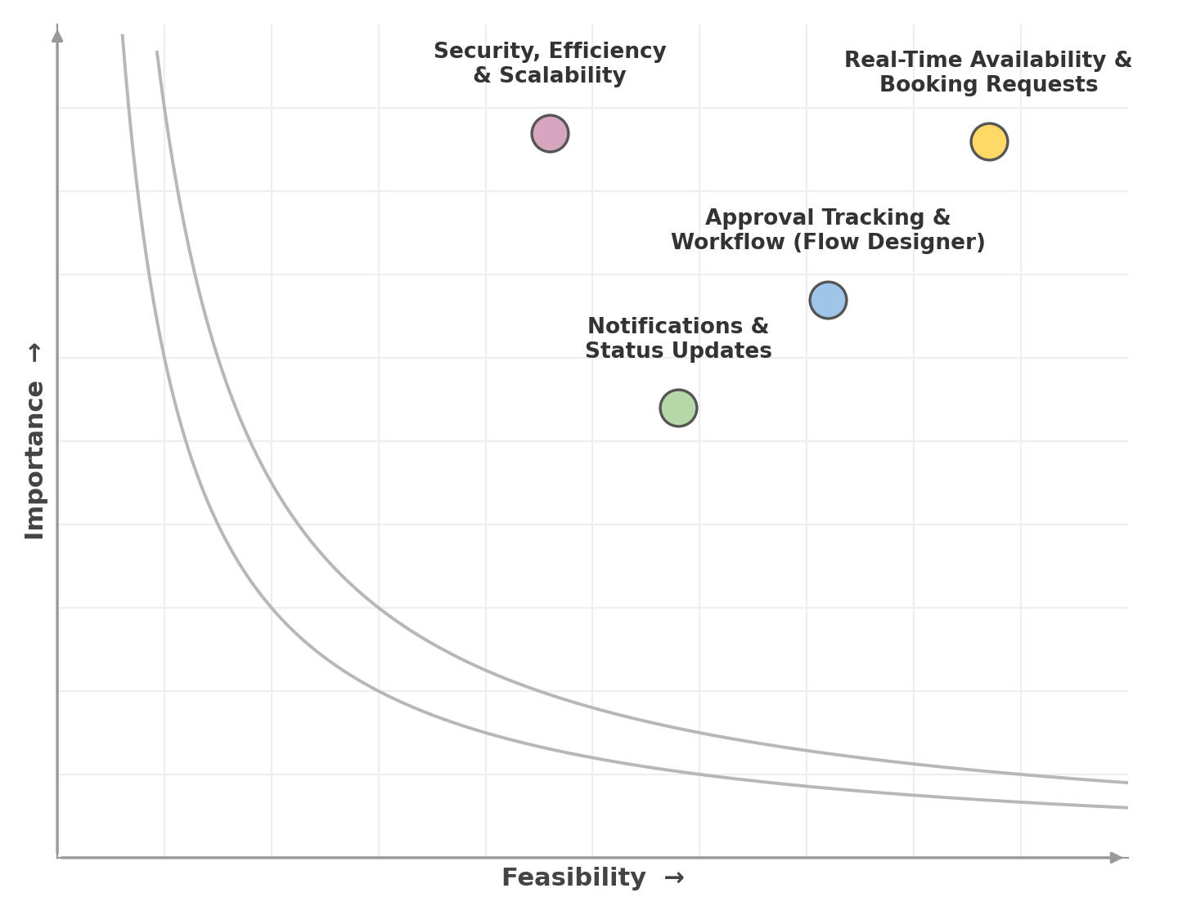
Importance — If each of these tasks could get done without any difficulty or cost, which would have the most positive impact?
Feasibility — Regardless of their importance, which tasks are more feasible than others (cost, time, effort, complexity, etc.)?

Based on the grid, Real-Time Availability & Booking Requests and Approval Tracking & Workflow were prioritized as the highest-impact, most feasible workstreams for the first release, while Security, Efficiency & Scalability was treated as a foundational, ongoing priority throughout development.

